l

Foundations of Programming

Assignment No. : 4
- PROBLEM STATEMENT: Write a C Program to calculate the salary of an employee given his basic pay (taken as input from the user). Calculate gross salary of employee. Let HRA be 10 % of basic pay and TA be 5% of basic pay. Let employees pay professional tax as 2% of total salary. Calculate net salary payable after deductions.

OBJECTIVE:

- To understand the importance of flowchart for any programming model.
- To learn simple flowchart symbols and arrows to define relationships.
- To understand and develop visual representations of flow of data.

THEORY:
- Define Algorithm.
- What are the different characteristics of an algorithm.

ALGORITHM :
Step 1: Start
Step 2: Declare variables basic, hra, ta, gross, tax, net
Step 3: Enter the basic salary from the user
Step 4: Calculate HRA
hra=0.10×basic
Step 5: Calculate TA
ta=0.05×basic
Step 6: Calculate Gross Salary
gross=basic+hra+ta
Step 7: Calculate Professional Tax
tax=0.02×gross
Step 8: Calculate Net Salary
net=gross−tax
Step 9: Display HRA, TA, Gross Salary, Tax and Net Salary
Step 10: Stop

FLOWCHART :
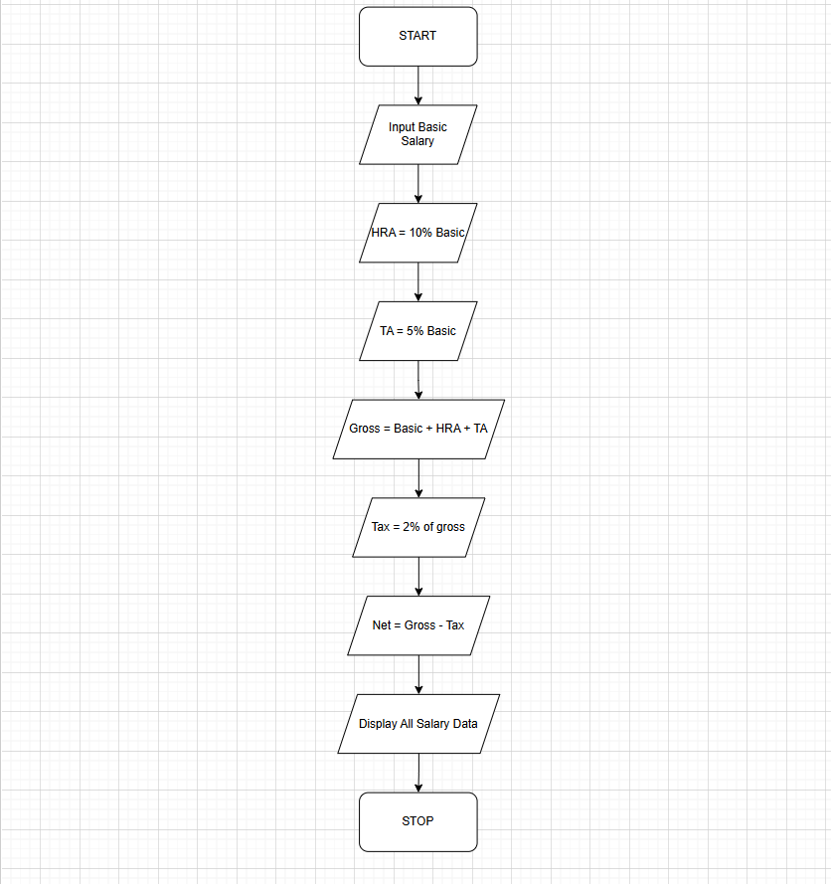
PLATFORM: Linux

CODE :
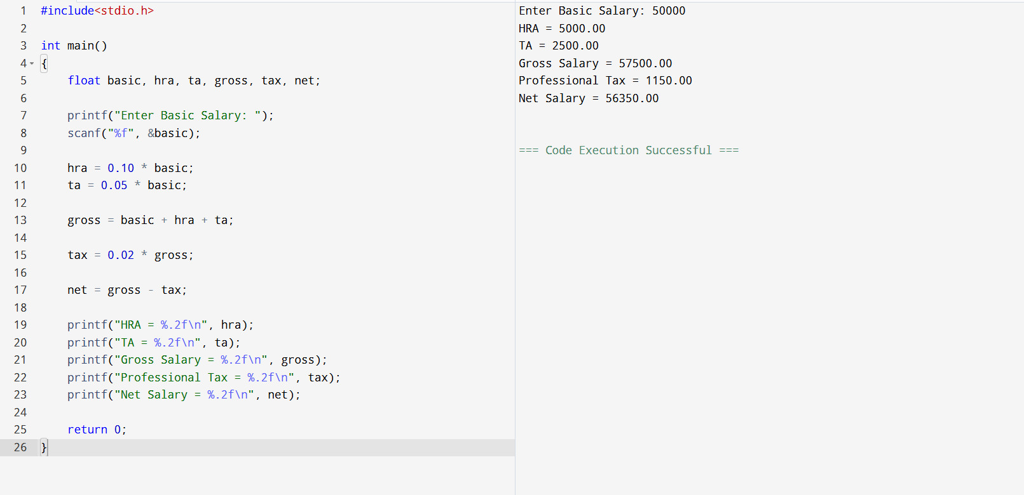

INPUT:

OUTPUT:
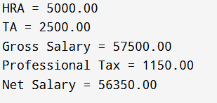
CONCLUSION: Thus, we have learned to write algorithms and to draw its representation in terms of flowchart.

FAQs:
- Describe various symbols and their use in flowchart.
- Difference between Algorithm and Flowchart.

